**Ionic Quick Installation guide**

1. Install Node.Js from the website <https://nodejs.org/en/> choose the version 16.17.1 LTS or the recommended for most users version
2. Open the CMD terminal in your machine
3. Go to the root directory which is C drive from:
   1.  to
   2. 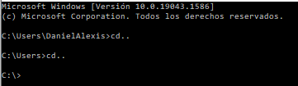
4. Run the npm installation command for ionic CLI which is 🡪 npm i -g @ionic/cli
5. After this run the npm installation command for Angular CLI which is 🡪 npm install r-g @angular/cli
6. Finally run the npm installation command for Cordova which is 🡪 npm install -g cordova

This will complete the full installation for the Ionic framework after this we can start with the creation of our first application.

1. Go to folder htdocs over the xampp folder
   1. 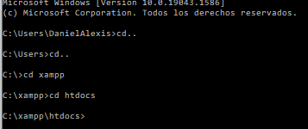
2. Run the command to start a new app inside the htdocs folders, which is 🡪 ionic start AppName blank this will create a new blank application.
3. Go to your new app folder so we can start running the app
   1. 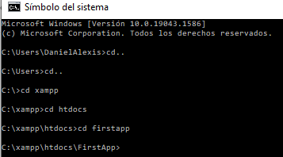
4. Run the command to start the app which is 🡪 ionic serve, this will start your application and it will be open shortly in the default browser

This concludes the process of creating and starting a new application.

**Glossary**

* cd 🡪 change directory
* cd.. 🡪 change directory back a level
* ionic start AppName blank 🡪 to start a new blank app in Ionic
  + tabs
  + blank
  + sidemenu
  + super
  + conference
  + tutorial
  + aws

This are few examples of the type of apps you can start to begin with more info at <https://ionicframework.com/docs/v3/cli/starters.html>

* ionic serve 🡪 to start your application
* ionic generate page PageName 🡪 to create a new module inside your Ionic app
* <https://ionicframework.com/docs/v3/ionicons/> 🡪 here you will find all the default icons available for the ionic apps
* <https://ionicframework.com/docs/theming/colors>→ here you will find the default theming colors available for the ionic apps
* npm install jquery --save → this is the command to install jquery on your project
* npm install sweetalert2 → this is the command to install sweetalerts on your project
* npm install @ionic/storage-angular → this is the command to install local storage on your project
* npm install cordova-plugin-camera -> this is the command to install the camera plugin on your project
* npm install @awesome-cordova-plugins/camera -> this is the command to install the camera plugin on your project
* npm install cordova-plugin-x-toast -> this is the command to install toast alerts on your project
* npm install @awesome-cordova-plugins/toast -> this is the command to install toast alerts on your project
* ionic capacitor sync -> this is the command to sync all the recent changes and libraries added to your project(recommended before starting an android build)
* ionic capacitor build android -> this is the command to add and build android assets
* ionic capacitor run android –list -> this is the command to find native devices where you can run your project
* ionic capacitor run android –devicename -> this is the command to run your project on the native device of choice